QUESTION :1
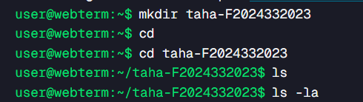

QUESTION :2
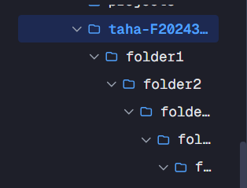

QUESTION :3
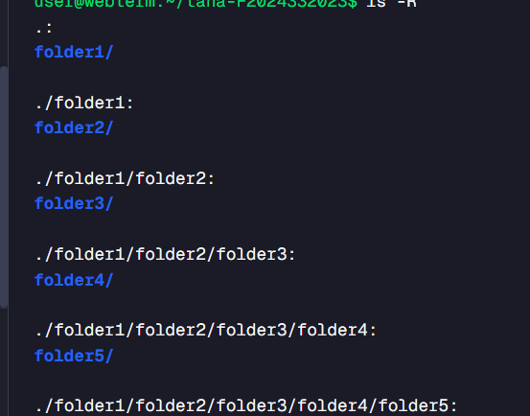

QUESTION :4

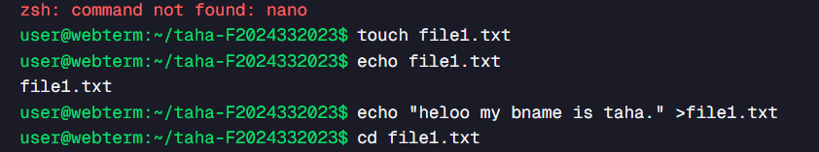

QUESTION :5


